WHAT IS CYBER SECURITY?
Cyber security is the practice of keeping digital information safe from theft, damage, or misuse. cyber security is practice of protecting computers, networks, systems, peoples and data from cyber attacks, unauthorized access and messages by using various technologies, processes and policies.
TYPES OF CYBER THREATS:
1. Cybercrime includes single actors or groups targeting systems for financial gain or to cause disruption.
2. Cyber-attack often involves politically motivated information gathering.
3. Cyber terrorism is intended to undermine electronic systems to cause panic or fear.

WHY CYBERSECURITY IS IMPORTANT?
Cyber security is critically important because it protects the sensitive, personal, and financial data of
individuals and organizations from being stolen, manipulated, or destroyed by
increasingly frequent and sophisticated cyber attacks(more frequent and modern cyber attacks)

SOME OF THE MAJOR POINTS :
1.Protects sensitive data
2.Prevents cyber sttacks
3.Prevents financial loss
4.Secures organizations and bussiness
5.Maintains trust and reputation
6.Ensures systems safety

TYPES OF HACKERS:
Mainly their are three type of hackers:
1.white hat(ethical/authorized): These are security experts who use their skills to protect organizations.
They operate with permission to identify vulnerabilities and strengthen security posture.
2.black hat(malicious/illegal):These individuals break into networks illegally for malicious reasons,
such as stealing data, installing ransom ware, or causing disruption for personal gain.
3.grey hat(unauthorized but not strictly malicious):These hackers operate between white and black hats.
They may access systems without permission (illegal) but generally do not have malicious intent,
often seeking to expose vulnerabilities to the owner.

but there are many other types of hackers :
1.script kiddies: They use ready-made hacking tools and don't have technical konwledge.
2.hacktivisits: Hackers who hack for political or social causes and attack websites to spread,messages
3.state/nation sponsored: Hackers supported by a government.Used for cyber espionage,
cyber warfare, or spying on other countries.
4.inside thrests:A person inside an organization (employee, ex-employee). They misuse internal access to steal or leak data.
5.red hat hackers:Red hat hackers fight against black hat hackers to protect systems from cyber attacks. They use strong hacking techniques to stop or destroy malicious hackers’ activities.
6.blue hat hackers:Blue hat hackers are security experts invited by companies to test their systems before launching software or products. Their job is to find vulnerabilities and help fix them to improve security.
7.green hat hackers:Green hat hackers are beginners who are learning hacking and cybersecurity. They have basic knowledge and are trying to improve their skills in the hacking field.

CIA Traid:The CIA Triad is a core framework in information security that helps organizations protect data and maintai secure, reliable systems.
1. Three principles: Confidentiality, Integrity, Availability.
C:Confidentiality: Ensures sensitive information is accessed only by authorized individuals.
Measures include encryption, 2FA (Two-Factor Authentication), and strict access control lists.
I:Integrity: Guarantees data is trustworthy, accurate, and has not been tampered with.
Techniques include file permissions, version control, and checksums
A:Availability: Ensures that authorized users have reliable access to data and resources when needed

1. This involves maintaining hardware, performing software updates, implementing disaster
recovery plans, and using DDoS protection.
2.Guides policies for protecting sensitive information.
3.Ensures data is secure, accurate, and accessible.

Cyber security Domains:
Cyber security are different areas of cybersecurity that focus on protecting systems, networks, and data. These domains are defined in the field of Cybersecurity.
following are the cybersecurity Domains:
1. Network Security :Protects computer networks from attacks such as hacking, malware, and unauthorized access. Example: Firewalls, IDS/IPS, VPN.
2. Application Security :Focuses on securing software and applications from vulnerabilities Example: Secure coding, penetration testing, patch updates
3. Information Security :Protects sensitive data from unauthorized access, modification, or deletion. Based on the CIA Triad (Confidentiality, Integrity, Availability).
4. Cloud Security :Protects data and services stored in cloud platforms.Example: Security in services like Amazon Web Services, Microsoft Azure, and Google Cloud.
5. Endpoint Security :Secures devices like laptops, mobiles, and desktops that connect to a network Example: Antivirus, device encryption.
6. Operational Security (OpSec):Focuses on processes and policies to protect sensitive information during operations.
7. Disaster Recovery & Business Continuity :Ensures systems and data can recover quickly after cyberattacks or disasters.

THREAT VS VULNERABILITY VS RISK
1. Threat
A threat is anything that can cause harm to a system, network, or data.Threats are external or internal actors (who/what).
Example: Hackers, malware, phishing attacks, or natural disasters.
TYPES:INTENSTIONAL,UNINTENSIONAL,NATURAL

2. Vulnerability
A vulnerability is a weakness or flaw in a system that attackers can exploit.Vulnerabilities are internal weaknesses (where).
Example: Weak passwords, outdated software, or open ports.
TYPES:NETWORK,OPERATING SYSTEM,PROCESS, HUMAN

3. Risk
A risk is the chance that a threat will exploit a vulnerability and cause damage.Risk is the calculated potential impact (what happens).
Example: If a system has outdated software (vulnerability), a hacker attack (threat) may cause data loss (risk).
TYPES:INTERNAL,EXTERNAL

Basic Security Cotrols:Basic security controls in cybersecurity are foundational measures—preventive, detective, and corrective—designed to protect information systems from threats.
Essential controls include multi-factor authentication (MFA), firewalls, regular patch management, data encryption, and employee security awareness training to prevent unauthorized access and mitigate risks.

common security ocontrols:
Authentication
Verifies the identity of a user using passwords, biometrics, or OTP.
Authorization
Determines what resources or data a user is allowed to access.
Access Control
Restricts access to systems and information to authorized users only.
Encryption
Converts data into a secure format so unauthorized users cannot read it
Antivirus / Anti-malware
Detects and removes malicious software from systems.
Backup and Recovery
Creates copies of data so it can be restored if data is lost or attacked.
Endpoint Security: Deploying endpoint detection and response (EDR) and antivirus tools to protect devices.
Network Security: Utilizing firewalls, intrusion prevention systems (IPS), and network segmentation to secure network traffic.
Malware: it is stands for malicious software that is any software designed to harm, damage, or gain unauthorized access to a computer, network, or data.
Malware is a harmful program created by attackers to:
- Steal data (passwords, bank)
- Damage systems
- Spy on users
- Take control of devices

Example : If you download a cracked software from an unknown site, it may contain malware that:
- Steals your login passwords
- Slows down your system
- Gives hackers remote access

Common Types of Malware:
- Virus – Attaches to files and spreads when you run them
- Worm – Spreads automatically across networks
- Trojan Horse – Looks safe but is actually harmful
- Ransom ware – Locks your data and asks for money
- Spyware – Secretly collects your information
- Adware – Shows unwanted ads

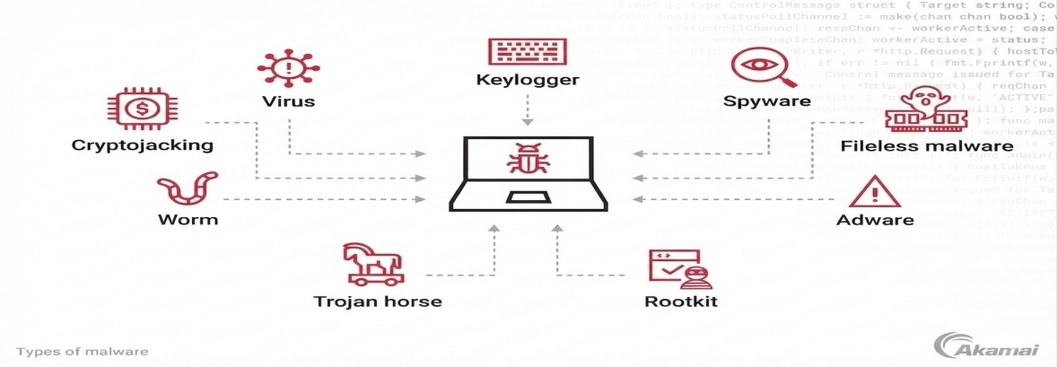

VIRUS:It can replicate itself and spread from one system to another system.it needs user action.

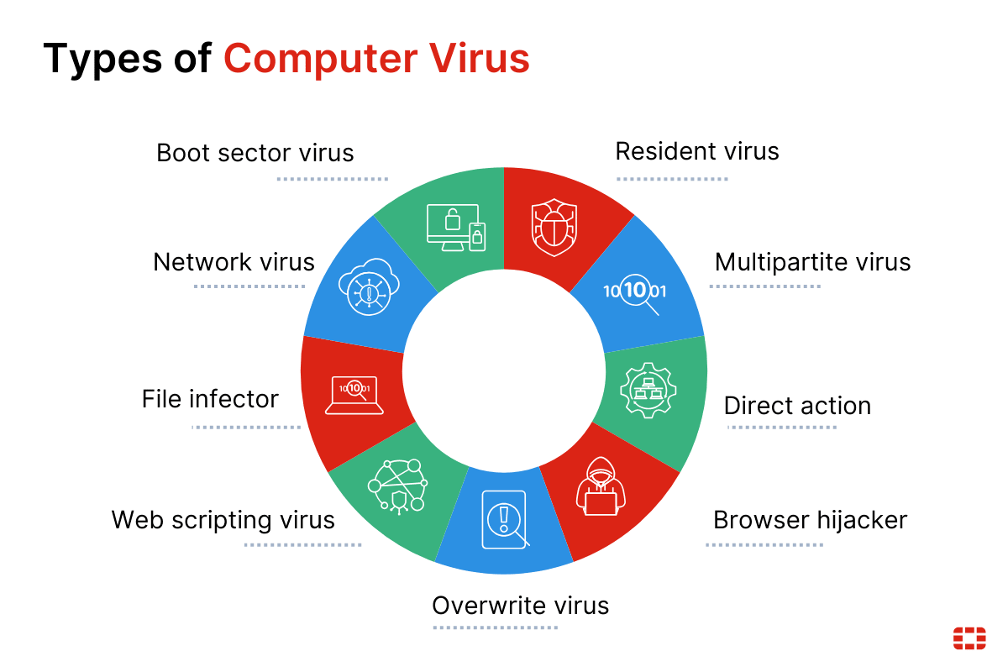
- It can enters yous computer without permission .
- It attacks to the files and softwares
- It Spreads when infected file is opened.
- It can damage the data, system can be slow down and steal(secretely copy your data)information.

CAUSES:
- It will come when you download an infected file (email,USB,website)
- Emails attachments.
- File sharing
- Messaging apps
- Pop message will arrives
TORJAN HORSE: A Trojan Horse (Trojan) is a type of malware that pretends to be a safe or useful program, but harms your system when you install or open it. It looks like real but secretly steal your data ,installs other malwares, give hackers to acces you data. They tricks users and then attack.

Example: It comes from the Trojan Horse story, where soldiers hid inside a wooden horse to enter a city secretly.
same as Trojan horse malware hides inside something that looks safe.
Working of Trojan horse :
- You download something (game, app, email attachment)
- It looks safe and you install/open it.
- Trojan gets activated in background.
- It starts stealing data or controlling your system

WORMS: A worm is a type of malware that can replicate itself and spread automatically across networks without any user action.
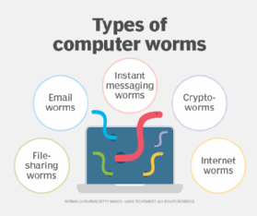
- It can enters through a vulnerability.
- Start copying itself.
- Spread to other computer on the same network or internet.
- Slow down system or damage.

PHISHING ATTACKS: A phishing attack is a type of cyber attack where an attacker tricks people into giving sensitive information by pretending to be a trusted person or organization
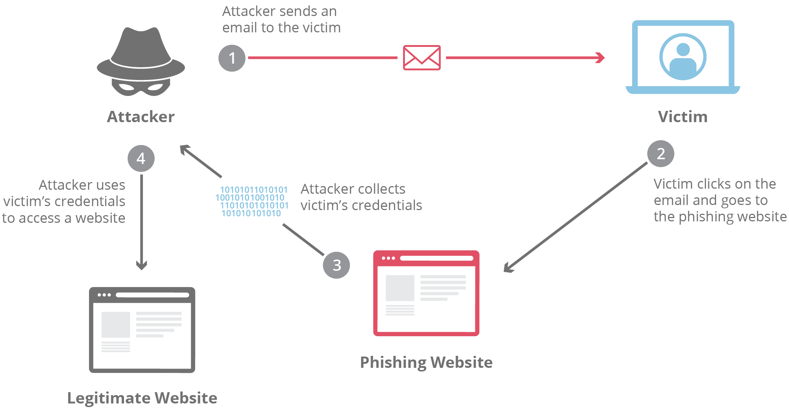

WORKING:
- Attacker sends a fake email/SMS/website link
- Message looks like it’s from a trusted source (bank, company, etc.)
- You click the link or open attachment
- You enter your details (password, OTP, card info)
- Attacker steals your information.
- They target your personal info like Passwords, bank details, OTP, personal data.

- RANSOM WARE : A ransom ware attack is a type of cyber attack where a hacker locks or encrypts your data and then demands money to unlock it but sometimes Even after paying, data may not be recovered.

WORKING :
- You click a malicious link or download a file
- Ransom ware gets installed in your system
- It encrypts (locks) your files.
- Hacker asks for payment (often in cryptocurrency)

- Avoid downloading from unsafe site
- Keep antivirus updated
- Take regular backups
- Don’t click on unknown links.

BACKDOOR ATTACKS: It is a hidden way to access a system without normal

Login and authentication. Attackers secretly creates o hidden way to enter a system , network or software without normal authentication(like passwd and security checks)

Example : it’s like someone secretly making a hidden door in your house so they can come and go anytime without using main lock.
- It will happens when malwares are installed a hidden access point.
- A hacker exploits a software vulnerability.
- A developer intentionally leaves a hidden access
- Weak security settings allow unauthorized entery

In this attack attacker access your files and data,steal your personal info and control system remotely, install more malwares, monitor your activities.

Protect your system …… don’t download cracked software, keep your system and apps updated,use antivirus and firewall, avoid suspicious links and emails,use strong passwd, don’t save paswd and passkeys.

DOS ATTACKS: A DOS attack (Denial of Service attack) is a cyber attack in which an attacker tries to make a computer system, website, or network unavailable to users by sending a large number of fake requests or traffic.
Example: If a hacker sends thousands or millions of requests to a website, the server gets overloaded and stops working for real users.
How it works:
- Attacker sends too many requests.
- System becomes slow or crashes.
- Genuine users cannot access the service.

DDOS ATTACK: A DDOS attack (Distributed Denial of Service attack) is a cyber attack where multiple computers are used to flood a system, website, or network with huge traffic, making it unavailable to real users.
How it works:
- Attacker controls many infected computers.(called botnet)
- These computers send massive requests to a target
- The server gets overloaded
- Real users cannot access the service
Note: A botnet is a group of hacked computers controlled by an attacker These computers unknowingly participate in the attack

DDOS attack effect on Website/server downtime, Business lose, Poor user experience, Network congestion

PRVENTS IT FROM Use firewalls & intrusion detection systems, Traffic filtering and rate limiting, Load balancing, Anti-DDOS protection services.

SOCIAL ENGINEERING: Social Engineering is a type of cyber attack where attackers manipulate people into giving confidential information instead of hacking systems directly.

